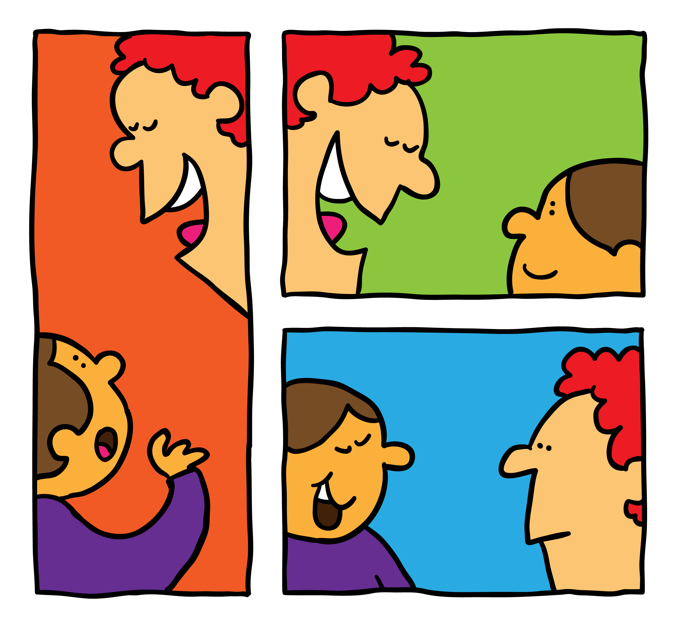

Independent Speech & Language Therapy. Belinda Robertson. Independent SLT.

Belinda Robertson, Independent Speech & Language Therapist, graduated from The City University, London in 1997, after having gained a 2:1 B.Sc. degree in Clinical Communication Studies (Speech and Language Therapy).

Her qualifications and registrations include: B.Sc. (Hons), Member of Royal College of Speech & Language Therapists (MRCSLT), Member of Association of Independent Speech & Language Therapists (MASLTIP), National Nursery Examination Board (N.N.E.B.) and Registered with Health Professionals Council (HPC). She is CRB enhanced checked.

Belinda has had an extensive & enjoyable 30 years working with children of all different ages and personalities! She originally started her career working as a private nursery nurse (N.N.E.B) and then went on to work as a Learning Support Assistant working with 'statemented' children with Special Needs in mainstream school.

Her 'Highly Specialist' speech and language therapy work in the NHS involved working in, and managing, the Speech & Language Therapy Service in Health Centers. She has a huge wealth of experience supporting statemented children in mainstream & special schools, working with children with delayed & disordered speech & language, autistic spectrum disorders, social communication disorders, Down's syndrome, Cerebral palsy, learning disability and childhood feeding & swallowing difficulties (paediatric dysphagia in the acute setting of the hospital). She has worked in special schools for both severe (PMLD) and moderate learning difficulties. Belinda is extremely experienced working in multi-disciplinary teams and in the education setting, along-side teachers and other associated professionals.

Her private therapy offers a flexible & holistic approach to therapy, to children from 1-16 years old. Therapy may include intensive and periodic therapy, usually in the familiarity of the child's own home or school. Initial assessments, indirect therapy (consultancy with parents & teachers) and/or direct therapy are the care pathways usually recommended.

Her specialist clinical fields include

- phonology & articulation (speech sound) delay & disorder
- oral/verbal dyspraxia
- oro-motor based therapy
- language delay (late talkers) & language disorder
- fussy feeding & eating, drooling & dribbling in children
- early/pre-school stammering
- pre-school special needs
- early play and communication
- parent/child interaction
- phonological awareness – early literacy skills
- hearing impairment – glue ear/conductive & sensori-neural loss
- Makaton/signing
- language and auditory processing difficulties
- I am a ‘Certified Practitioner’ of ‘ The Listening Program’ – see www.thelisteningprogram.com

She has a specialist post-graduate qualification in paediatric dysphagia (feeding & swallowing), is 'Makaton' signing trained and has completed further training in; non-directive play therapy, Downs Syndrome, verbal & oral dyspraxia, early language acquisition, early stammering, colour coding, Picture Exchange Communication System (PECS), Social Stories and cleft lip & palate, fussy feeding & eating…… to name but a few.

Additionally, Belinda has tutored outside of the NHS, on nurse training courses with her 'dysphagia' specialism, supervised SLT & nurse students, is a mother herself and a Community Governor at a local 'Outstanding' Nursery School.

In order to comply with professional standards, maintain registration to both the Royal College of Speech and Language Therapists (RCSLT) & The Health Professionals Councils (HPC), and to fulfill Continued Professional Development (CPD) she attends formal courses, further study, supervision sessions and study groups on a regular basis. She is both BUPA and AXA/PPP recognised.
_____________________________________________________________________________________________________________________

B.Sc. (Hons). MRCSLT. MASLTIP. Registered Member Health Professionals Council (HPC).
(01462) 649173. Mob: 07887 942450. sltbelinda@gmail.com
